# Part 4

Using describe function,



The dataset consists of 2 columns (date and close columns) with 4425 observations:

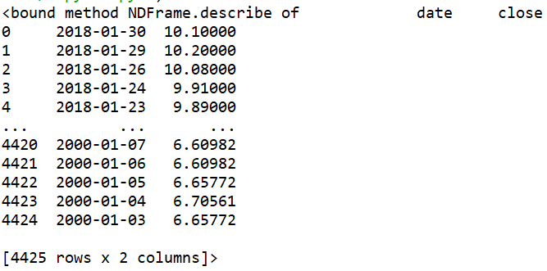

Use isnull function to check for null values and use sum function to calculate total count of null value:



There is no null value in the data:

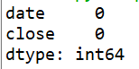

Use dtypes function to check the data type of columns in dataframe:



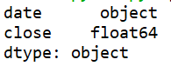

Since there is no null value and the data are in correct data type, there is no data cleaning needed.

Perform trend analysis by plotting line graph:

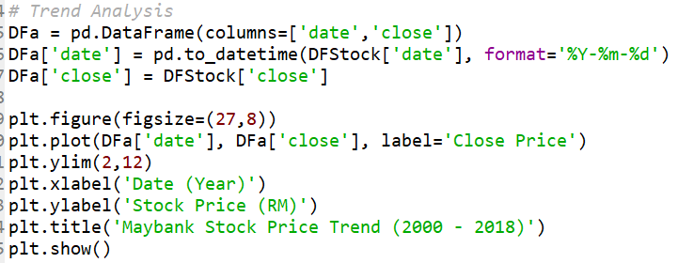

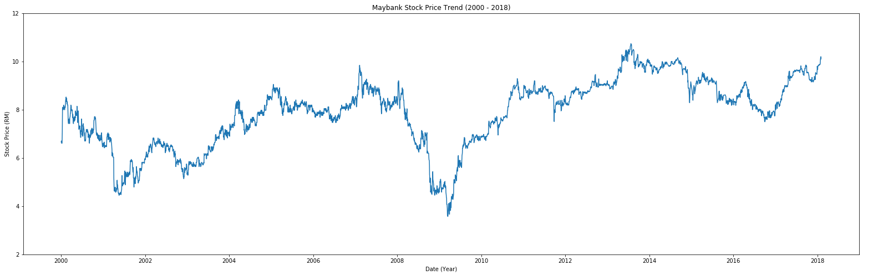

Next, perform statistical calculation on the dataset, which include mean, minimum, maximum and percentile at 0, 25, 50, 75, 90 and 100:

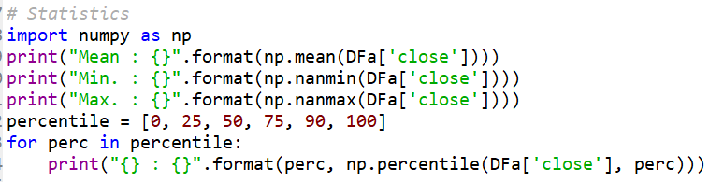

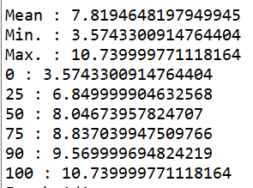

There is no extreme value / outlier and there is no zero in close price.

Use Long Short Term Memory algorithm to predict stock price based on dataset provided. The dataset is split into train and validation dataset at the ratio of 60:40. MinMaxScaler is applied to close price to transform the data onto the scale of 0 to 1 before performing prediction using LSTM machine learning model. Once prediction is executed, close price is transformed back to its original form using inverse_transform function:

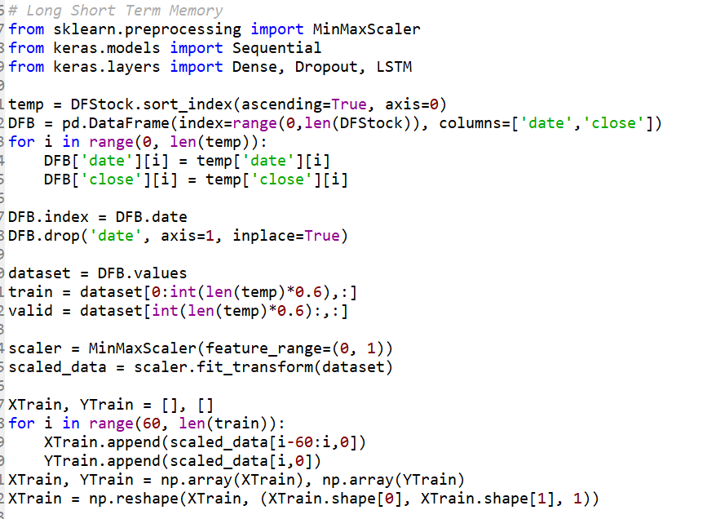

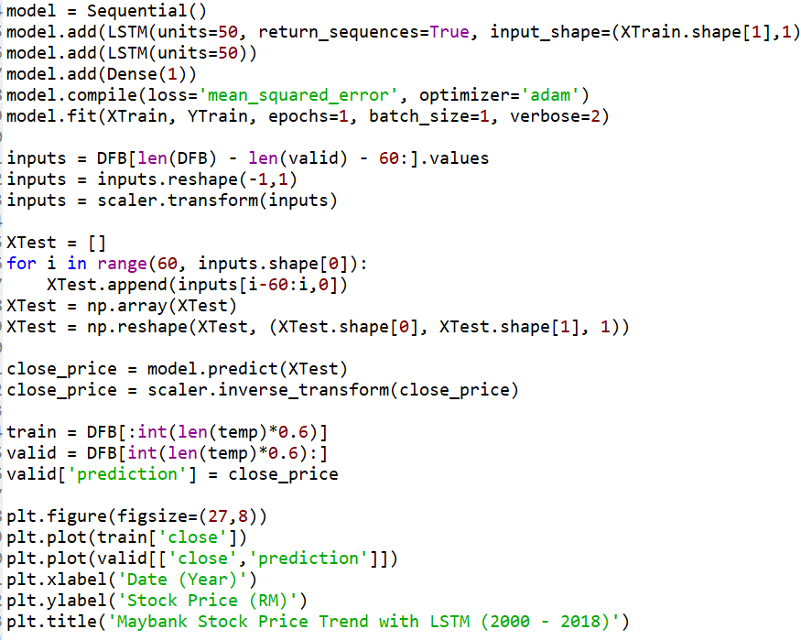

The predicted price is compared to the real data from validation dataset:

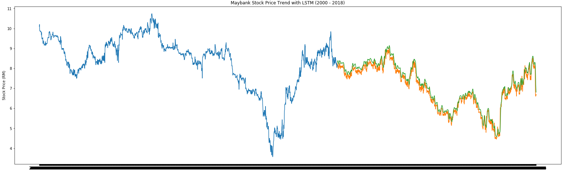

The predicted price is pretty close to the actual close price.

To compare MBB stock price against KLSE index, first use line chart to compare their trend:

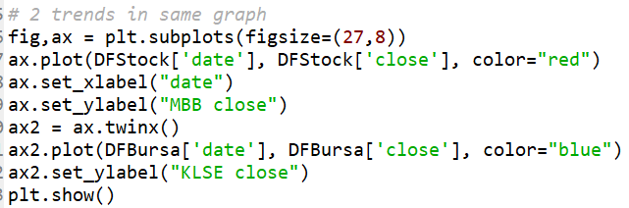

Red line represents MBB’s close price while blue line represents KLSE’s index:

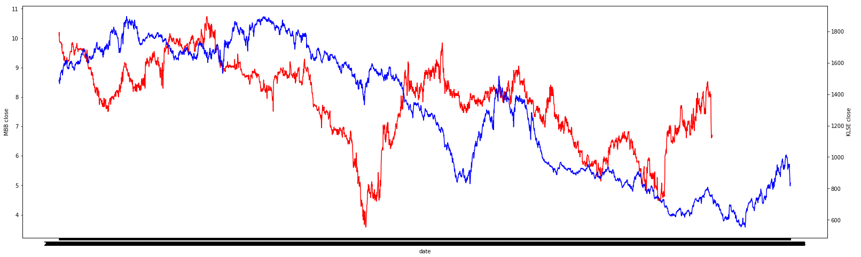

The trend of both MBB stock price and KLSE index have similar pattern whereby both increase and drop in tandem, although MBB stock price happens at a slightly later timeframe.

Next, to find out correlation between MBB stock price and KLSE index after merging them into single dataframe:



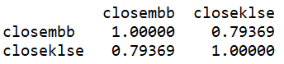

As expected, there is a relatively strong positive correlation between MBB stock price and KLSE index at 0.79369.

And finally to visualize the correlation between MBB stock price and KLSE index using scatter plot:

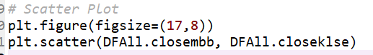

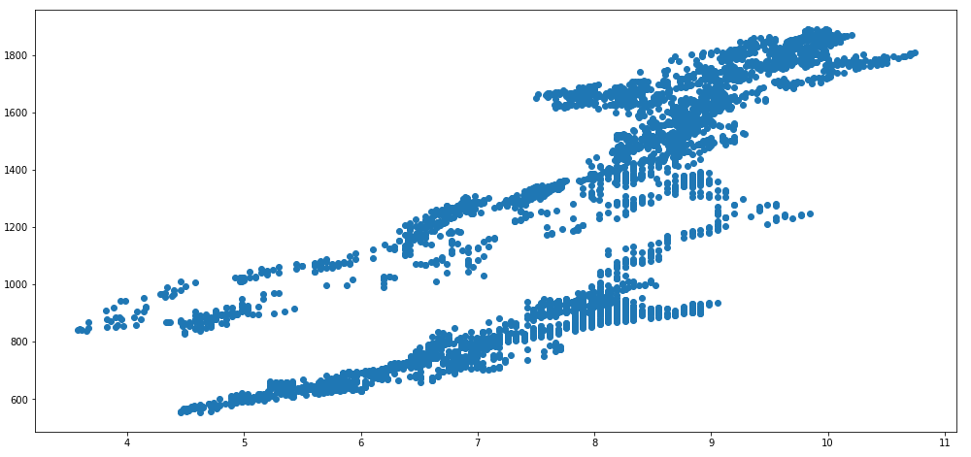

The plotted scatter plot supports the relatively strong positive correlation between MBB stock price and KLSE index.